Definitely Maybe Encrypted
A combination of malware analysis techniques and unorthodox encryption weaknesses
Difficulty: Medium
Benjamin Poulton
Abertay HackSoc Term 1 CTF 25/26

Introduction
“Known Evil” is a challenge where users have to extract a encrypted ZIP file resource from an EXE file. They must then decrypt the contents of this EXE file, by using the tool “bkcrack” to extract the archive’s keys using a known plaintext.
Challenge description
“Discovered this EXE file. I'm sure there's more to it than it seems, and I know I've seen the name before somewhere.”
The user is provided with an EXE file titled bkcrack.exe. (THIS IS NOT THE TOOL NEEDED)

Solution
The provided EXE file has a section header titled .OASIS, and checking this shows it starts with the file signature of a zip file. Extracting this resource from the EXE will provide the user with a password protected zip file including the flag, a copy of jquery-3.7.1.min.js, and a placeholder HTML file.
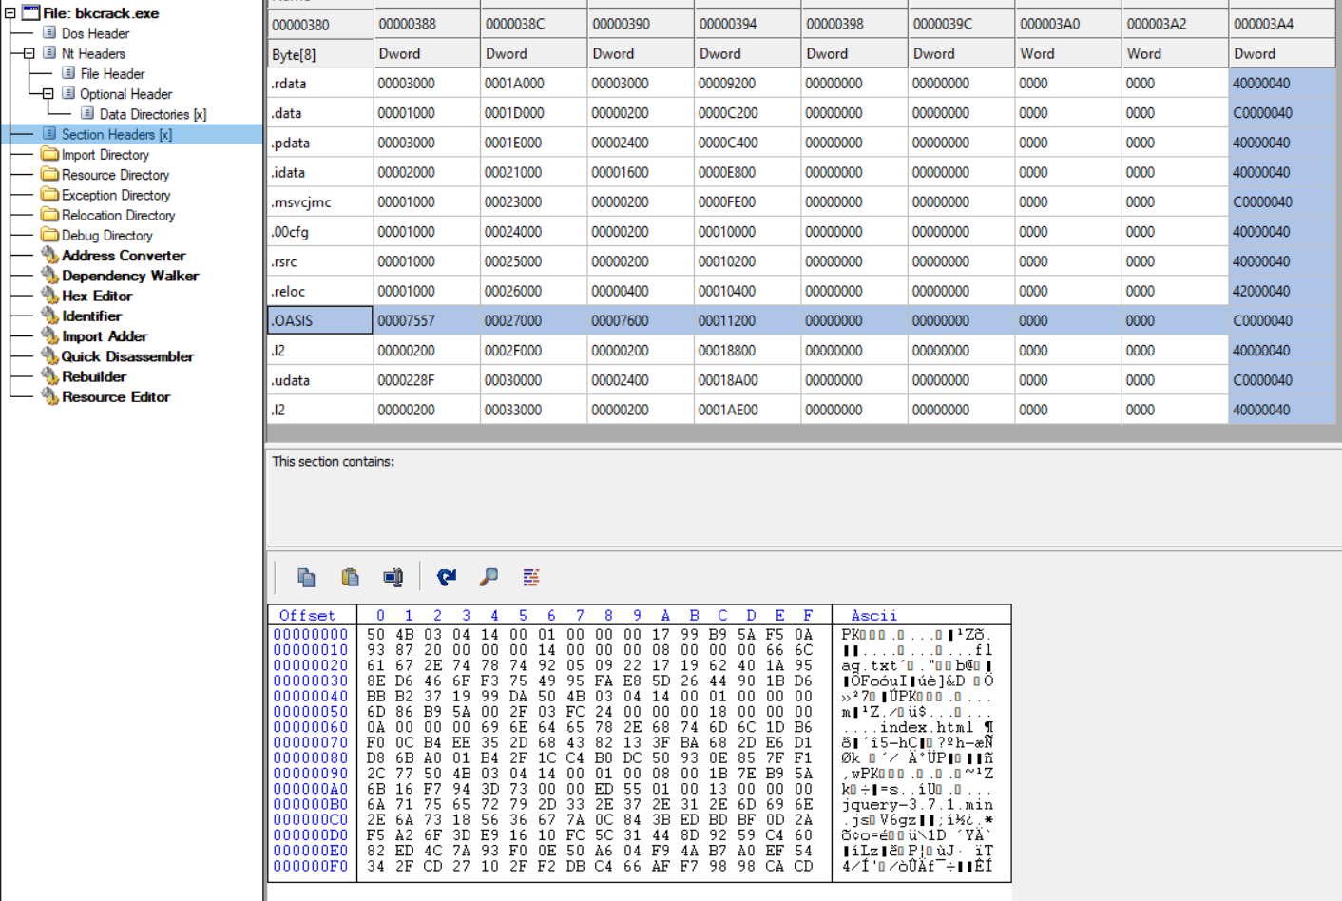
The zip file contains a base64 encoded comment, that simply states the ZIP archive was created using 7zip 24.09, and as the archive contains a well known file (jquery-3.7.1.min.js), it is possible to perform a known plaintext attack on the ZIP file. This requires the user to create an unencrypted zip using the same compression method (7zip 24.09, deflate, normal compression), before using bkcrack to generate the key used.
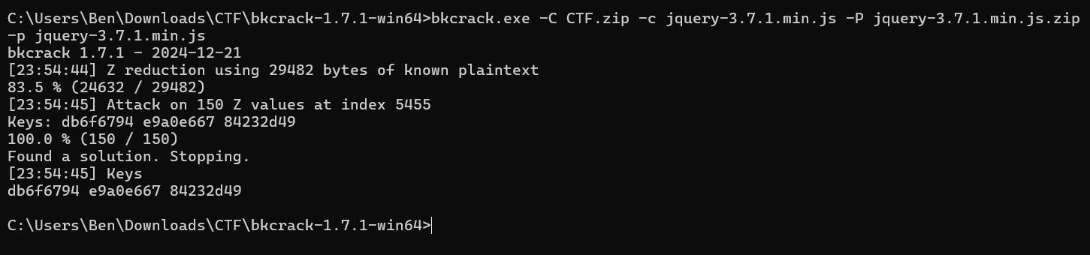
this key can then be used to generate a new archive with the same files, but without any encryption, meaning the flag can be viewed.
